EQUIJOIN
SELECT EMPLOYEES.EMP_NAME,EMPLOYEES.DEP_ID FROM EMPLOYEES,DEP1 WHERE EMPLOYEES.DEP_ID=DEP1.DEP_ID;
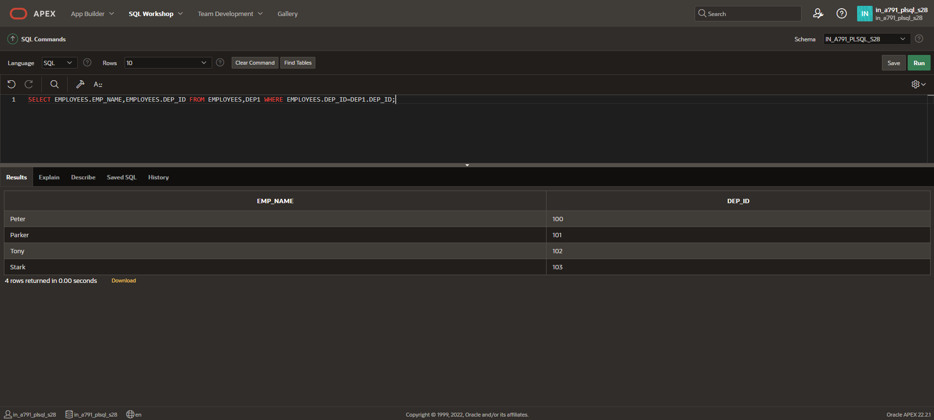
TABLE ALIAS
SELECT e.EMP_ID, e.EMP_NAME, e.DEP_ID FROM EMPLOYEES e JOIN DEP1 j ON e.DEP_ID = j.DEP_ID;
